**QUESTION 1**

**Nextline()**

The ****nextLine()**** method of the ****Scanner**** class is also used for taking input from the user. In order to use the nextLine() method, we also need to create an instance of the Scanner class. The nextLine() method is capable of reading input till the end of the line. So, it stops reading input from the user when the user presses the enter key or line change.

**Example:  
public** **static** **void** main(String[] args)  
  { Scanner sc = **new** Scanner(System.in);  
 System.out.println(“enter string”)  
  String Input = sc.nextline();  
  System.out.println(“String”+Input);  
**Input:**   
Enter string Great Pakistan  
**Output:**    
Enter string Great Pakistan  
String Great Pakistan

**Next()**

The next() method of the Scanner class is used for getting input from the user. In order to use the ****next()**** method of the Scanner class, an instance of the Scanner class needs to be created. The next() method stops reading input from the user until it receives a white space(" "). So, it returns the next complete token from the Scanner.

**Example:  
public** **static** **void** main(String[] args)  
  { Scanner sc = **new** Scanner(System.in);  
 System.out.println(“enter string”)  
  String Input = sc.next();  
  System.out.println(“String”+Input);  
**Input:**   
Enter string Great Pakistan  
**Output:**    
Enter string Great Pakistan  
String Great

**QUESTION 2**

**Take a number from the user and check if it is even or odd**

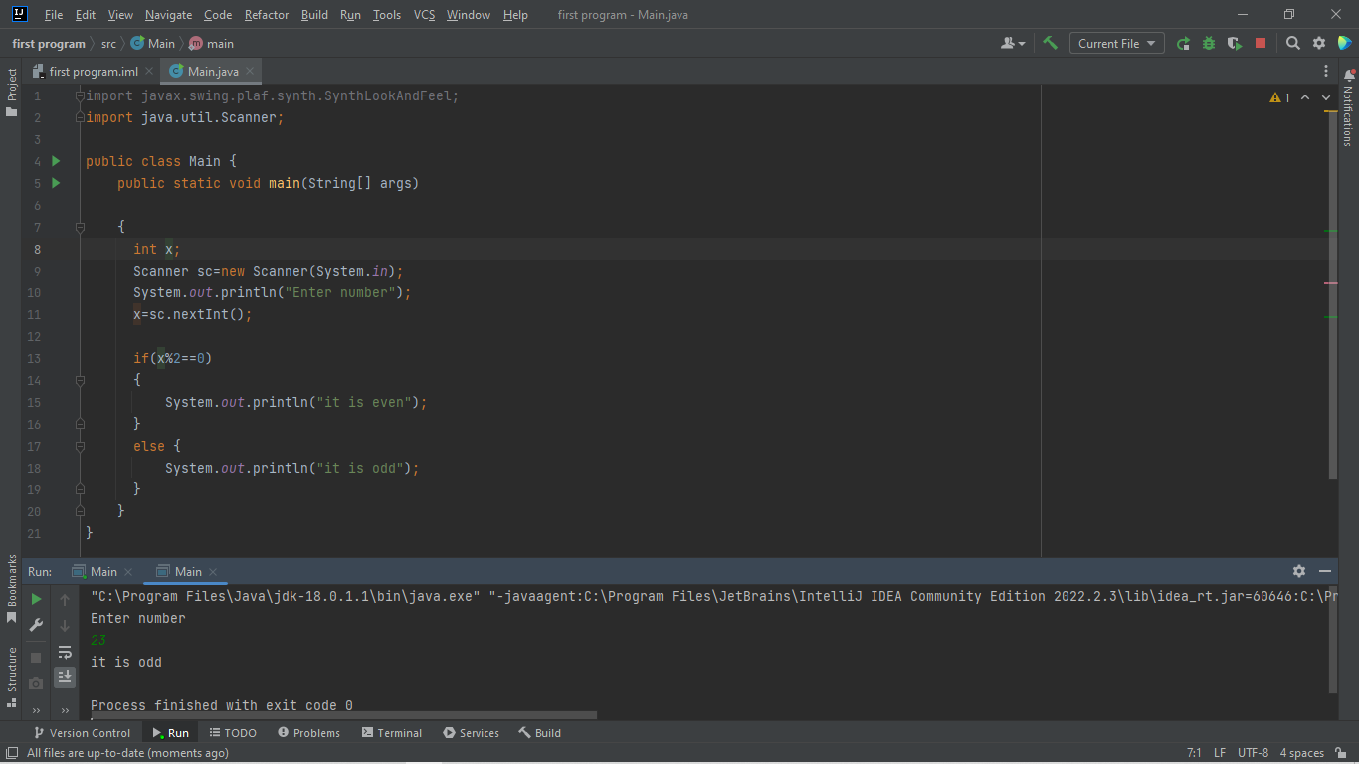

**QUESTION 3**

**Code of printing the big number**

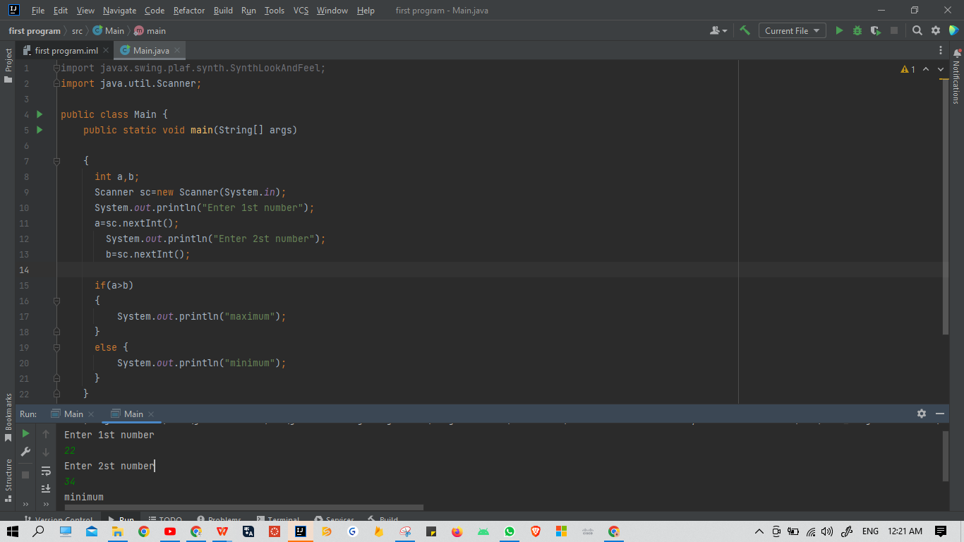

**QUESTION 4**

**Find leap year or not**

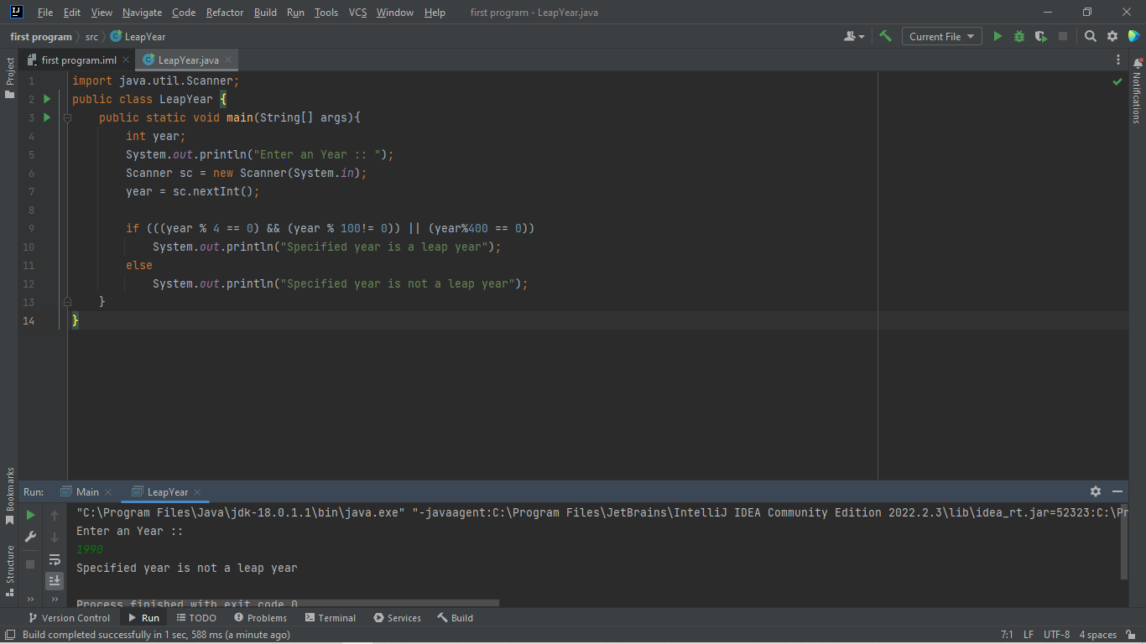

**Question 6**

**Write an application that inputs one number consisting of five digits from the user, separates**

**\* the number into its individual digits and prints the digits separated from one another by three**

**\* spaces each.**

**\* For example, if the user types in the number 42339, the program should print**

**\* 4 2 3 3 9**

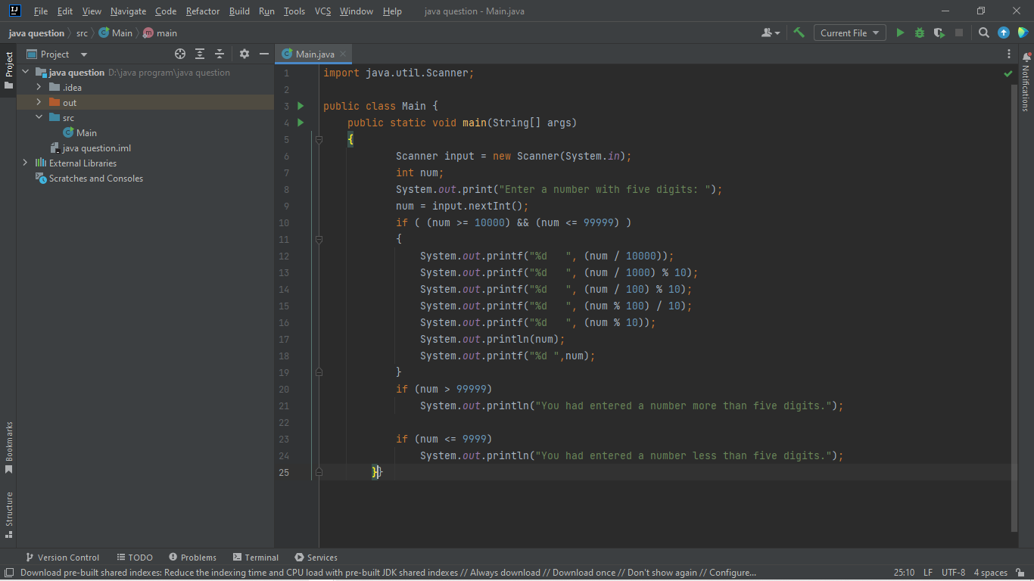

**Question 7**

**Is question mein ap value enter karty ho and us kah square and cube nikal kar ata ha**

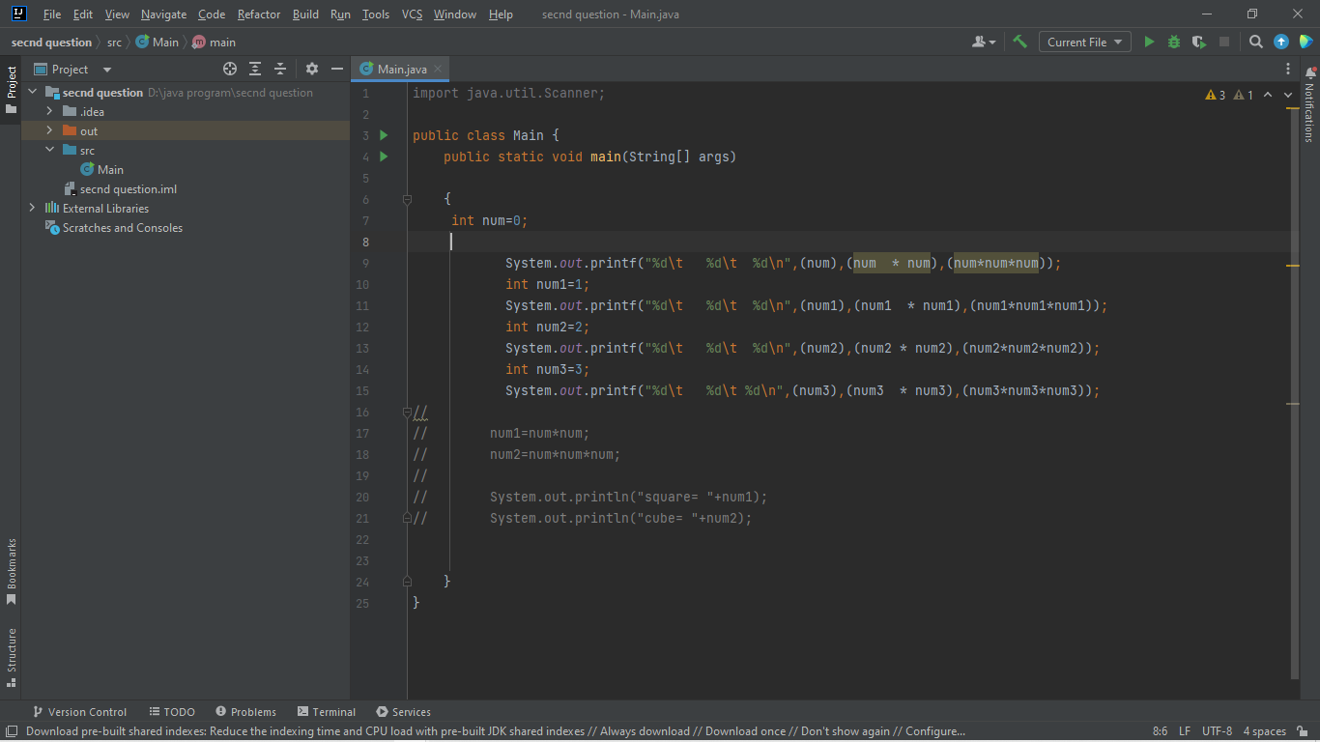

**Question 8**

# **A shop will give discount of 10% if the cost of purchased quantity is more than 1000.Ask user for quantity Suppose, one unit will cost 100. Judge and print total cost for user. in java​**

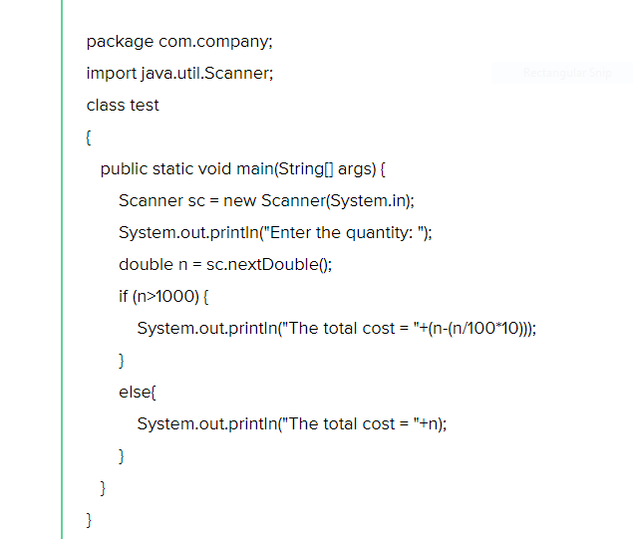

**Question 9**

**Program to print absolute value**

*public* *class* Example {

*public* *static* *void* main(String[] args) {

*float* value1 = -5.67f;

*long* value2 = -654L;

System.out.println(Math.abs(value1));

System.out.println(Math.abs(value2));

}}